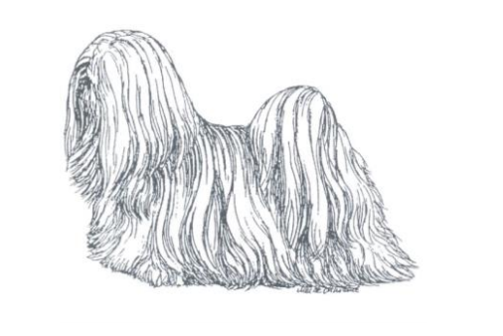
the Lhasa Apso Club of the Czech Republic
cordially invites you to
Special club show of the Lhasa Apso Club Czech Republic
with awarding of titles: Winner of the Special club show,
Junior Winner and Winner of Veterans

on Saturday 2nd October, 2021
in hotel AVANTI BRNO
www.hotelavanti.cz
judge: Sabina Chiesa-Folbrecht
( change of referee reserved )

I. closing date for applications : 10th May, 2021
II. closing date for applications : 20th August, 2021

Program of the exhibition
09:00 – 10:00 Dog reception
10:30 Opening of the exhibition in the ring
Enters only on: www.dogoffice.cz.

Learn more about the exhibition at www.klublhasaapso.cz.

Classification:

Baby class 4 to 6 months
Puppy class 6 to 9 months
Junior class 9 to 18 months
Intermediate class 15 to 24 months
Open class from 15 months for all dogs regardless of the awards received
Champion class from 15 months accessible for dogs with recognised title: the International or National champion, the National winner, the Club winner, the Winner of the Special Exhibition, the European or World winner
Veteran class from 8 years
Honorary class from 15 months for dogs with recognised title: the International or National champion, the National winner, the Club winner, the Winner of the Special Exhibition, European or World winner, without entitlement to CAC. The stamp is entered in the order according to the ČMKU Exhibition Rules. Both dog and bitch with the V1 award advance to the competition for the BOB and BOS titles.

The age of the dog on the day of the exhibition is decisive for inclusion in the class. If the dog is born on the same day as the exhibition is held, the owner decides which class to include the dog in (before the deadline).
Classification:
Excellent, Very good, Good, in the Junior class, Intermediate class, Open class, Veteran class and the Honorary class the order of 4 dogs with the mark Excellent or Very good is determined.
Very promising, Promising – in the class of puppies and baby
Titles:
CAJC, CAC, res. CAC
Winner of Special club show , all CAC compete, dogs and bitches compete separately
Junior Winner of Special club show, all CAJC compete, dogs and bitches compete separately
Veterans Winner of Special club show, all V1 compete, dogs and bitches compete separately
BOJ – Best of Juniors, a young dog and bitch with CAJC
BOV – Best of Veterans, a dog and bitch with title Best of Veterans
BOB – Best of Breed, dogs and bitches with titles BOJ, BOV, the Winner of Special club show dogs and bitches with Ex.1 from honorary class.
BOS – Best of Opposite Sex dogs and bitches with titles BOJ, BOV, the Winner of Special dog show and dogs and bitches awarded in Ex 1 honorary class, opposite sex than the individual who received the title of BOB
Competitions:
The Best Couple, a dog and a bitch who were judged at the exhibition and belong to the same owner
The Best Breeding Group, a minimum of 3 and a maximum of 5 individuals who were judged at the exhibition, from one kennel and are at least two different mothers or fathers. It must not belong to one owner.
Veterinary conditions:
- all dogs and bitches taking part in the exhibition must be clinically healthy
- they must have a passport for small animals or a vaccination card and a valid vaccination against rabies, as required by the Veterinary Act, Section 4, Paragraph 1-f
- must be immune to canine distemper, leptospirosis, arboviruses

Fees: I. closing date II. closing date
classes: Puppy, Adolescence, Veteran and Honorary CZK 300 / EUR 20 CZK 450 / EUR 20
classes: Open, Intermediate, Young and Champions CZK 700 / EUR 35 CZK 850 / EUR 35
competitions CZK 200 / EUR 10 CZK 200 / EUR 10
catalogue CZK 40 / EUR 3 CZK 40 / EUR 3

Unpaid applications will not be accepted. It is not possible to pay at the exhibition.
Cancellation of the application does not warrant reimbursement of exhibition fees.
A change classification to another class by the exhibitor is only possible until the closing date II for a fee of CZK 100 / EUR 5. At the venue, it is possible to enter the competition until 10:15 am for a single fee of CZK 300 (only in CZK).
Exhibition conditions:
- Exhibition conditions according to the ČMKU Exhibition Rules
The exhibition is open only to dogs and bitches that are registered in the herd books of the FCI.
The exhibitor is obliged to follow the organizer's instructions and propositions.

- The organiser shall not be liable for any illness of dogs, death or loss and shall not be liable for any damage caused by a dog during the exhibition. Damage caused by a dog is the responsibility of its owner or exhibitor. Free running of dogs in the hotel where the exhibition is held is not allowed. The exhibitor is obliged to promptly remove the excrement after his dog.
- Sick dogs, trauma dogs, bitches in the 2nd half of pregnancy, dogs in heat, dogs biting and aggressive towards other dogs or humans are excluded from participation in the exhibition.
- If the exhibition is not held for reasons of force majeure, the exhibition fees will be used to cover the costs associated with the preparation of the exhibition.
- Protest for formal reasons (violation of exhibition regulations or propositions) is possible during the exhibition. It must be submitted in writing with a principal of CZK 1000 to the exhibition committee. When the protest is rejected, the principal is forfeited in favour of the exhibition organiser. There's no way to protest the umpire's decision.
- The exhibitor agrees to publish his name and address in the catalogue. By submitting the application, they agree to these propositions.

